|  |  |  |  |
| --- | --- | --- | --- |
|  | | | |
| **Expt. No:** | | **10** | **Common Emitter Characteristics & Common Emmiter Amplifier** |
|  | | |
| **Date:** |  | |
|  | | | |

**Aim:**  To study, the Input-Output characteristics of a BJT in Common Emitter Configuration. Also implement Common Emitter Amplifier.

**SOFTWARE TOOLS / OTHER REQUIREMENTS:**

1. Multisim Simulator/Circuit Simulator

# Theory:

The most frequently encountered transistor configuration appears in Fig.10.1 for the pnp and npn transistors. It is called the common-emitter configuration because the emitter is common to both the input and output terminals (in this case common to both the base and collector terminals). Two sets of characteristics are again necessary to describe fully the behavior of the common-emitter configuration: one for the input or base–emitter circuit and one for the output or collector–emitter circuit. Both are shown in Fig. 10.2 (a) and 10.2 (b) respectively.



Fig. 10.1



Fig. 10.2 (a) CE Input Characterisitcs



Fig. 10.2 (b) CE Output Characterisitcs

**input characteristics**

The input characteristics are a plot of the input current ( *IB* ) versus the input voltage ( *VBE* ) for a range of values of output voltage ( *VCE* ). The curve describes the changes in the values of input current with respect to the values of input voltage keeping the output voltage constant.

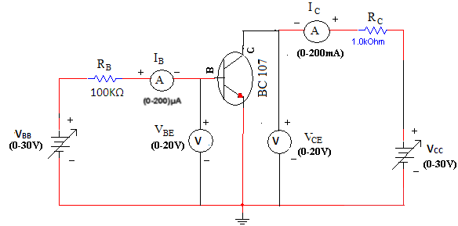

Fig. 10. 3 Circuit Diagram to obtain CE Input/Output Characteristics

**procedure**

1. **Connect the circuit as shown in the circuit diagram.**
2. **Keep output voltage VCE = 0V by varying VCC.**
3. **Varying VBB gradually, note down base current IB and base-emitter voltage VBE.**
4. **Step size is not fixed because of non linear curve. Initially vary VBB in steps of 0.1V. Once the current starts increasing vary VBB in steps of 1V up to 5V.**
5. **Repeat above procedure (step 3) for VCE = 3V.**

**output characteristics**

The output characteristics are a plot of the output current ( *I C* ) versus output voltage ( *V CE* ) for a range of values of input current ( *I B* ). The curve describes the changes in the values of output current against output voltage keeping the input current constant.

**procedure**

1. **Connect the circuit as shown in the circuit diagram.**
2. **Keep emitter current IB = 0µA by varying VBB.**
3. **Varying VCC gradually in steps of 1V up to 5V and note down collector current IC and Collector-Emitter Voltage(VCE).**
4. **Repeat above procedure (step 3) for IB = 20µA and 60µA.**

**input characteristics**

**Circuit diagram (from multisim)**

**observation table**

|  |  |  |  |  |
| --- | --- | --- | --- | --- |
| **VBB** | **VCE = 0V** | | **VCE = 3V** | |
| **VBE**  **(in Volts)** | **IB**  **(in µA)** | **VBE**  **(in Volts)** | **IB**  **(in µA)** |
| **0** |  |  |  |  |
| **0.1** |  |  |  |  |
| **0.2** |  |  |  |  |
| **.** |  |  |  |  |
| **.** |  |  |  |  |
| **0.9** |  |  |  |  |
| **1** |  |  |  |  |
| **1.5** |  |  |  |  |
| **.** |  |  |  |  |
| **.** |  |  |  |  |
| **5** |  |  |  |  |

**graph**

**calculations**

Input impedance = hie = Ri = ΔVBE / Δ IB (VCE = constant) = __________.

Reverse voltage gain = hre = Δ VEB / Δ VCE (IB = constant) =________.

**output characteristics**

**Circuit diagram (from multisim)**

**observation table**

|  |  |  |  |  |  |  |
| --- | --- | --- | --- | --- | --- | --- |
| **VCC** | **IB =0 µA** | | **IB =20 µA** | | **IB =60 µA** | |
| **VCE**  **(in Volts)** | **IC**  **(in mA)** | **VCE**  **(in Volts)** | **IC**  **(in mA)** | **VCE**  **(in Volts)** | **IC**  **(in mA)** |
| **0** |  |  |  |  |  |  |
| **0.1** |  |  |  |  |  |  |
| **0.2** |  |  |  |  |  |  |
| **.** |  |  |  |  |  |  |
| **0.9** |  |  |  |  |  |  |
| **1** |  |  |  |  |  |  |
| **1.5** |  |  |  |  |  |  |
| **.** |  |  |  |  |  |  |
| **5** |  |  |  |  |  |  |

**graph**

**calculations**

Output admittance 1/hoe = Ro = Δ IC / Δ VCE (IB is constant) =_________.

Forward current gain = hfe = Δ IC / Δ IB (VCE = constant) = ___________.

**Part – B**

**common emitter amplifier**

All types of transistor amplifiers operate using AC signal inputs which alternate between a positive value and a negative value so some way of “presetting” the amplifier circuit to operate between these two maximum or peak values is required. This is achieved using a process known as Biasing. Biasing is very important in amplifier design as it establishes the correct operating point of the transistor amplifier ready to receive signals, thereby reducing any distortion to the output signal.

The aim of any small signal amplifier is to amplify all of the input signal with the minimum amount of distortion possible to the output signal, in other words, the output signal must be an exact reproduction of the input signal but only bigger (amplified).

To obtain low distortion when used as an amplifier the operating quiescent point needs to be correctly selected. This is in fact the DC operating point of the amplifier and its position may be established at any point along the load line by a suitable biasing arrangement. The best possible position for this Q-point is as close to the center position of the load line.

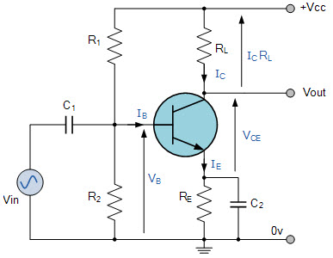 Common Emitter Amplifier Circuit

**180 DEGREE PHASE SHIFT**

In CE amplifier configuration, there will always a phase-shift of 180 degrees between the input and output as described in figure below.



**Circuit diagram from multisim**

**input – output waveforms**

**Conclusions**